LAB 9

1. echo $PS1

echo $PS2

PS1=”Akansha Katiyar:”

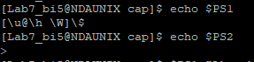



1. vi ~/.bashrc

PS1=”Akansha Katiyar”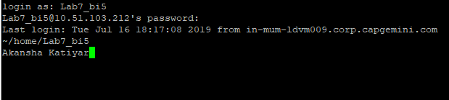

1. echo $SHELL

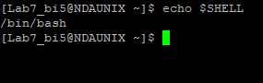

1. continent=”Africa”

echo “$continent”

sh

echo “$continent”

continent=”Asia”

echo “$continent”

ctrl + d

echo “$continent”

sh

echo “$continent”

ctrl + d

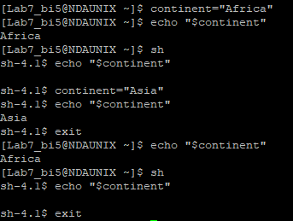

1. continent=”Africa”

export continent

echo “$continent”

sh

echo “$continent”

continent=”Asia”

echo “$continent”

ctrl + d

echo “$continent”

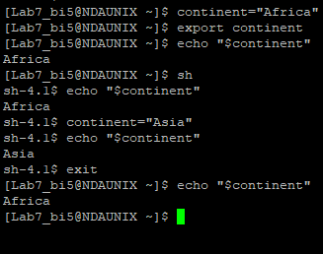

1. echo "Enter username"

read user

status=0

for i in $(who | awk '{print $1}' | uniq )

do

if [ "$user" == "$i" ]; then

status=$(($status+1))

fi

done

if [ $status -eq 1 ]; then

echo "User is logged in"

else

echo "User either does not exist or is not logged in"

fi

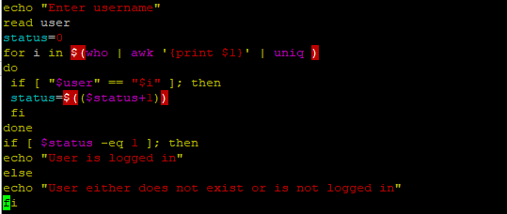

2. echo "Enter file name:"

read filename

if [ -f $filename ]; then

echo "$filename exists and its permissions are:"

ls -l $filename | cut -d " " -f1

else

echo "$filename does not exist"

fi

